Wireframe

Mockup

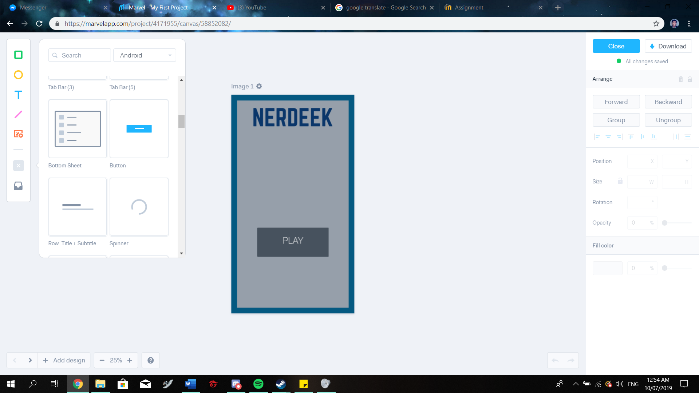 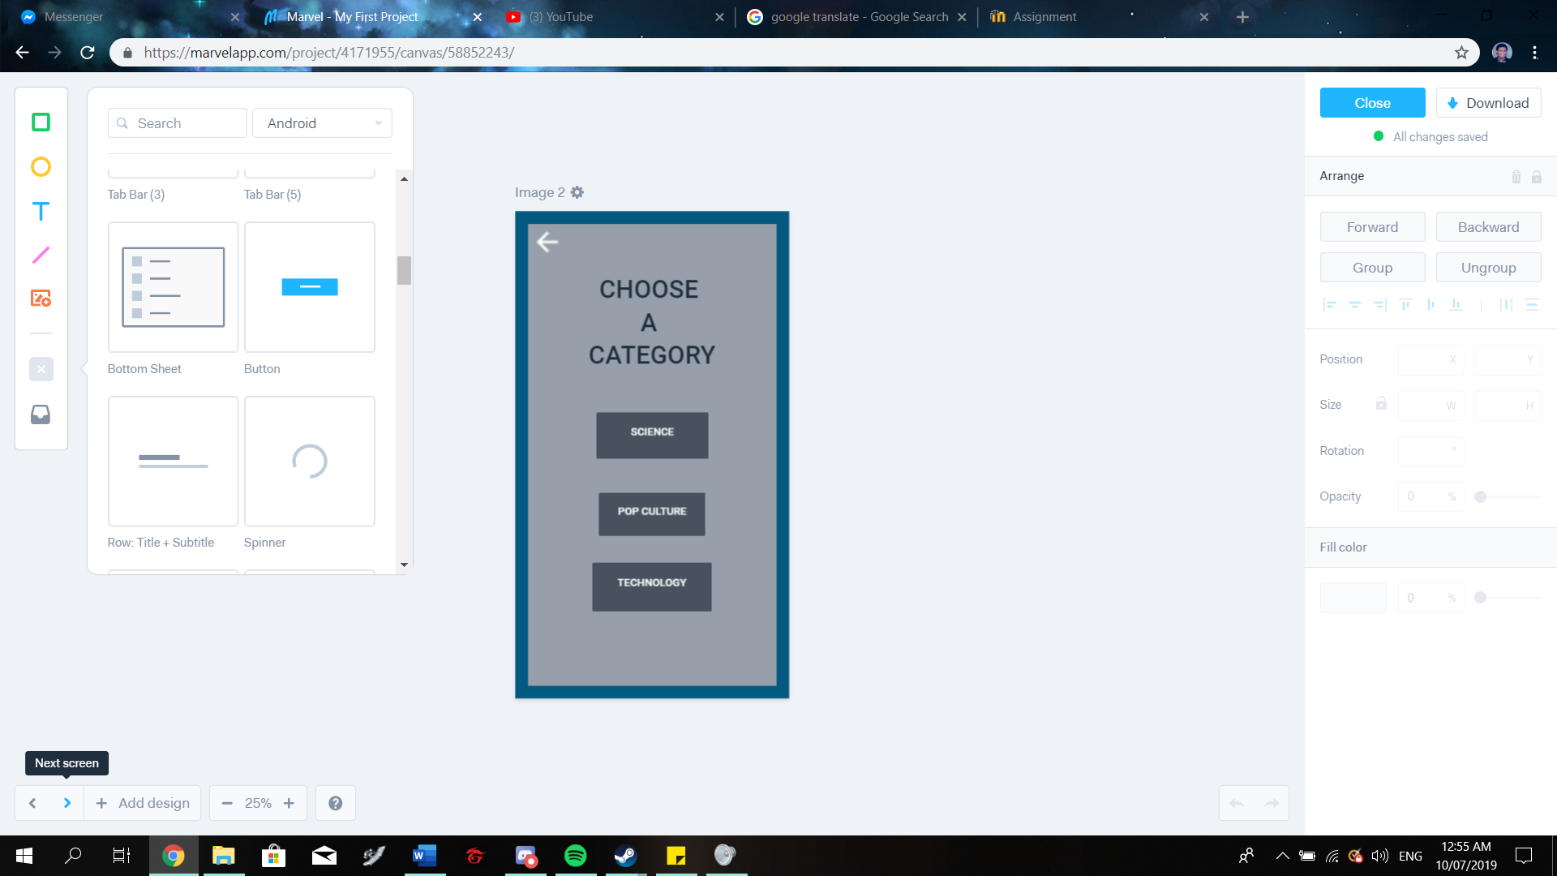

This is the category screen. The user can choose the category of his/her choice. The user can also return to the title screen by selecting the back button.

This is the Title screen. The user will be directed here upon launch

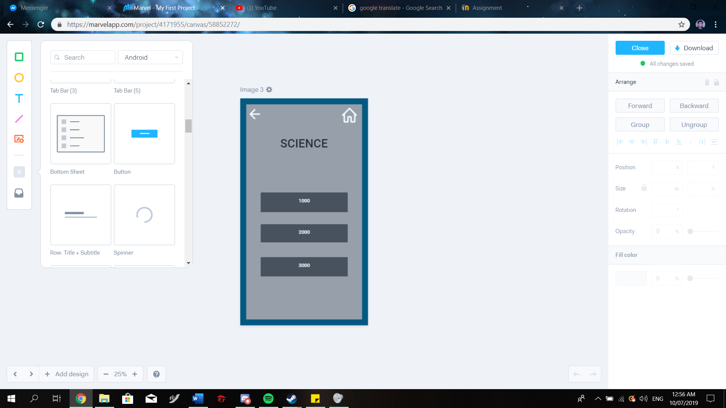 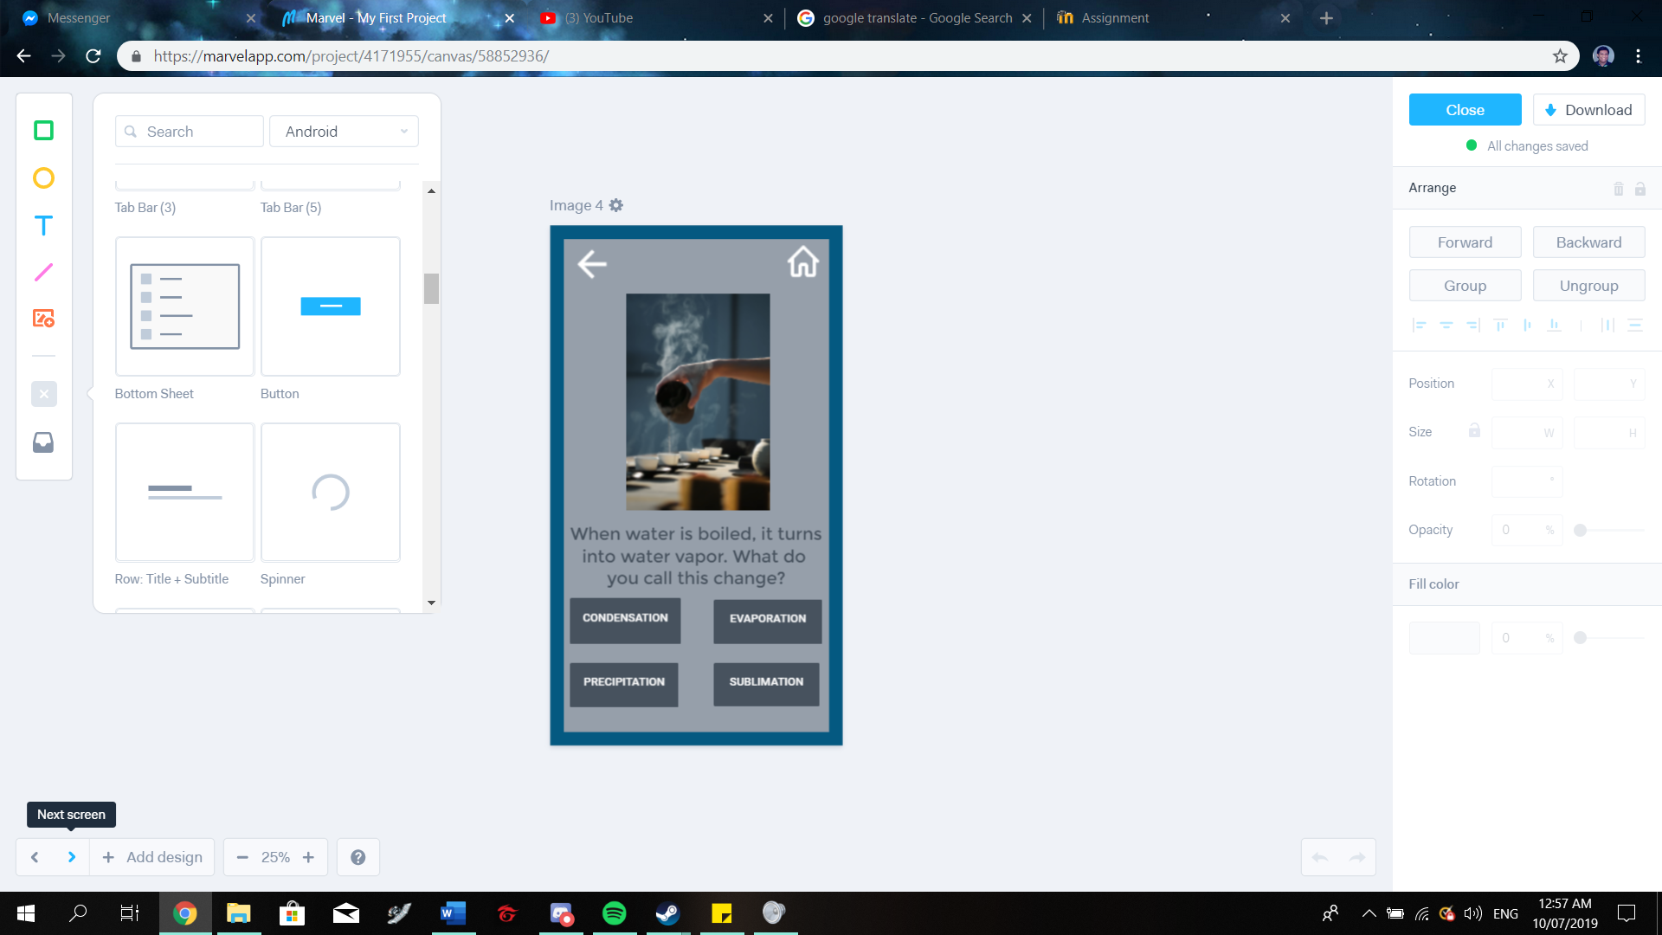

Upon choosing a category, the user can choose the question to be answered. The questions will have different scores depending on difficulty. The user can return to the previous page or title screen via back and home buttons

A sample question.

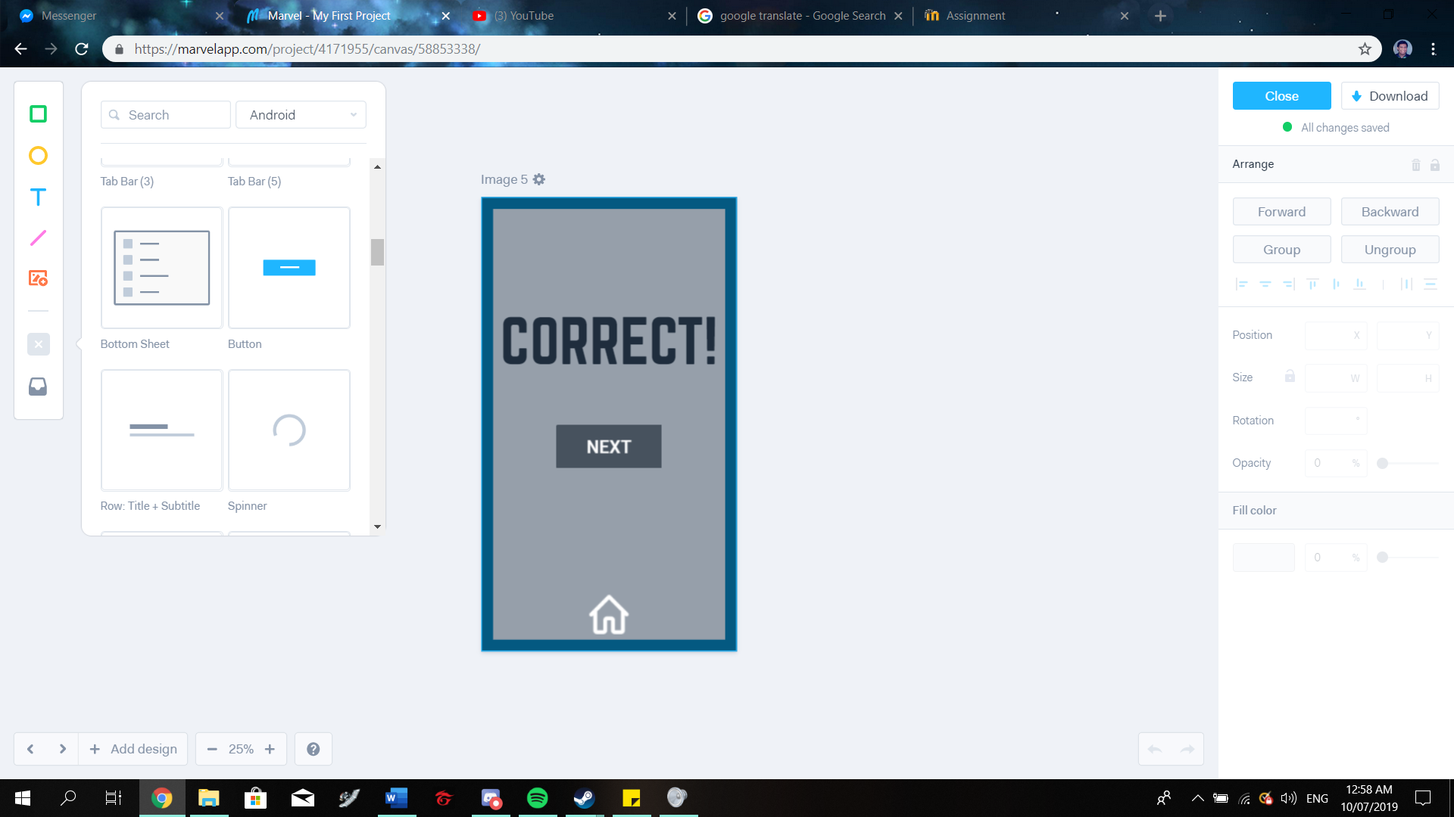 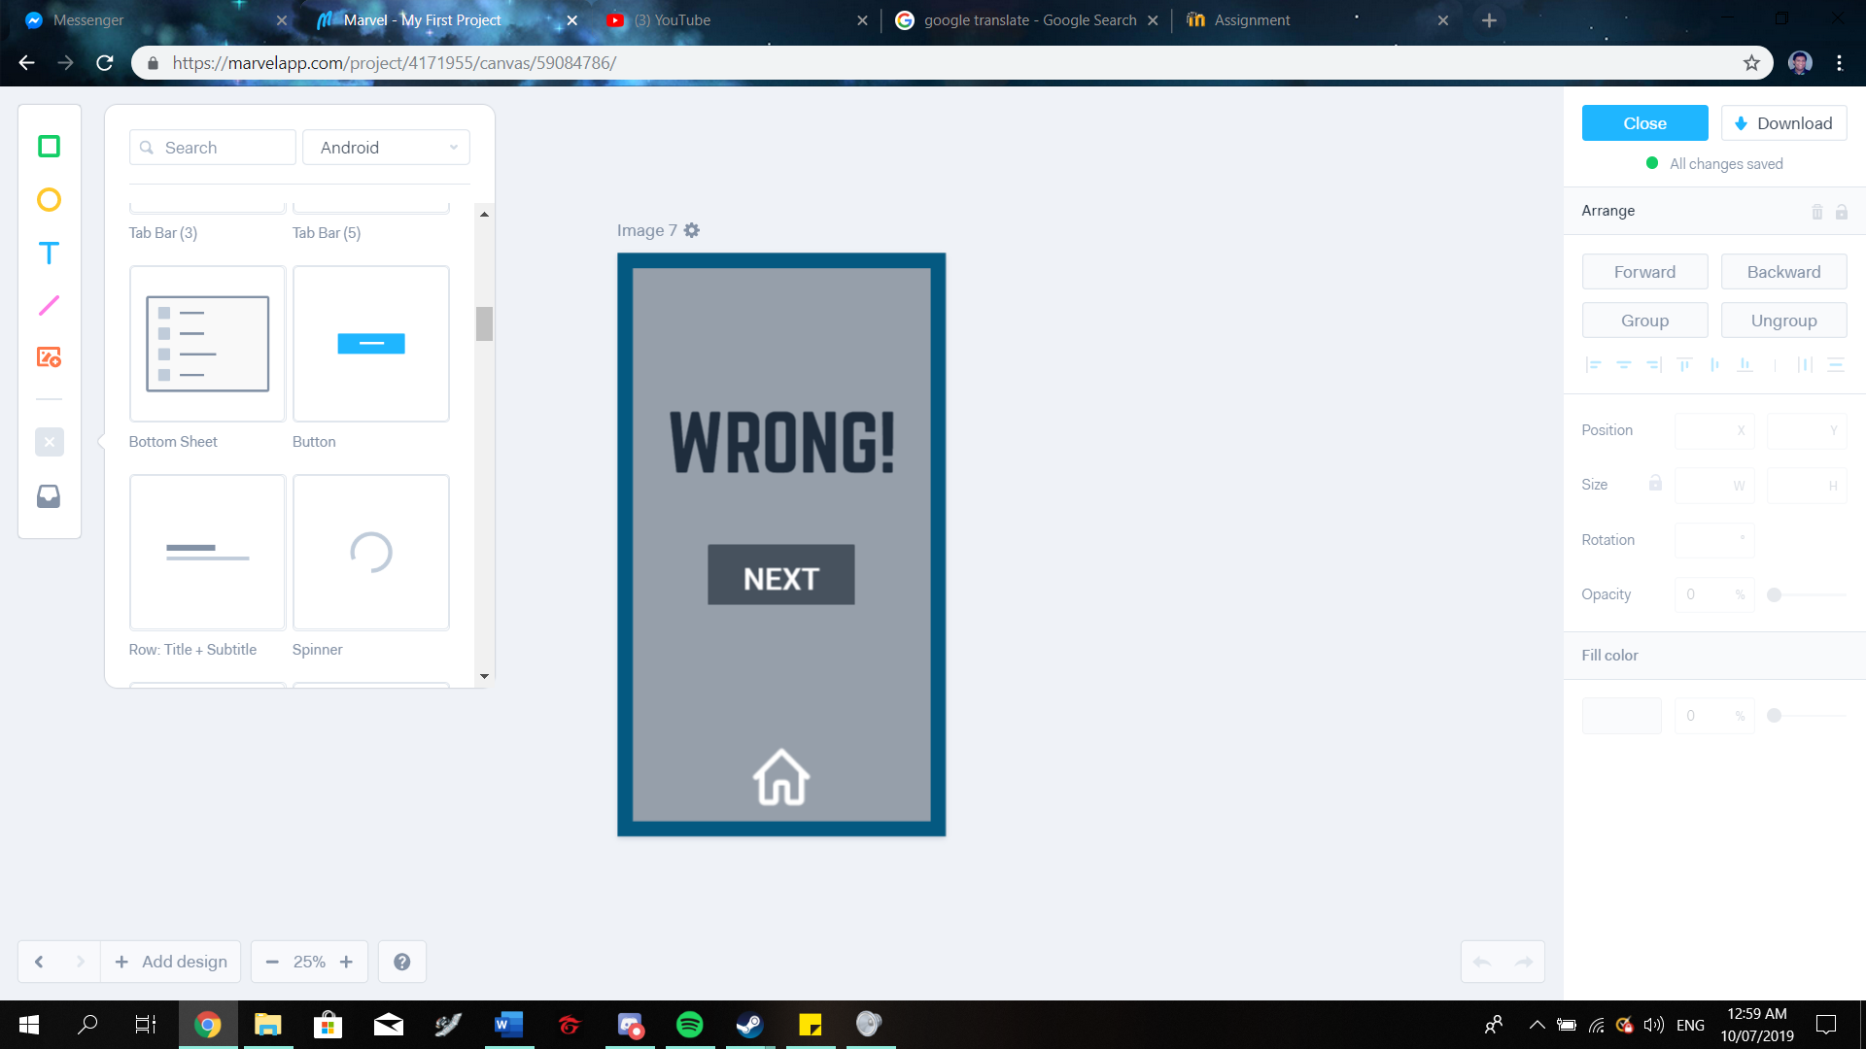

The result screens. If the user answers correctly, the correct screen will appear, if not, then the wrong screen will play out. Both screens have a ‘next’ button that will return to the question selection screen. Both screens also have a home button if the user wishes to return to title screen

Prototype

Link: <https://marvelapp.com/76g0e13>

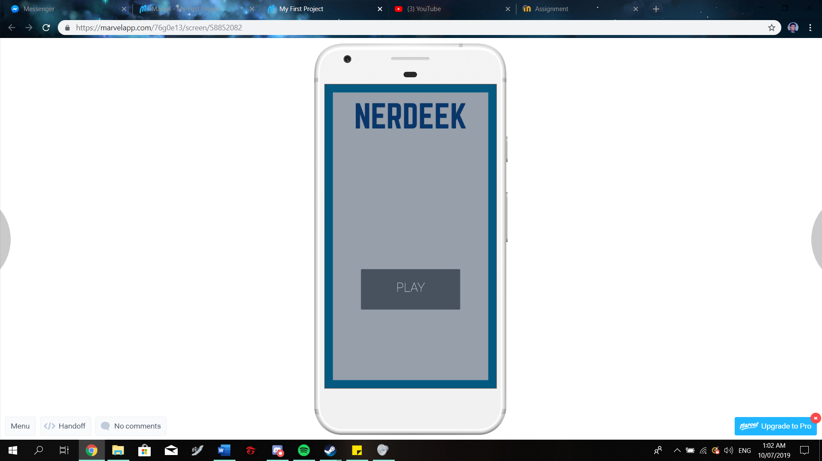 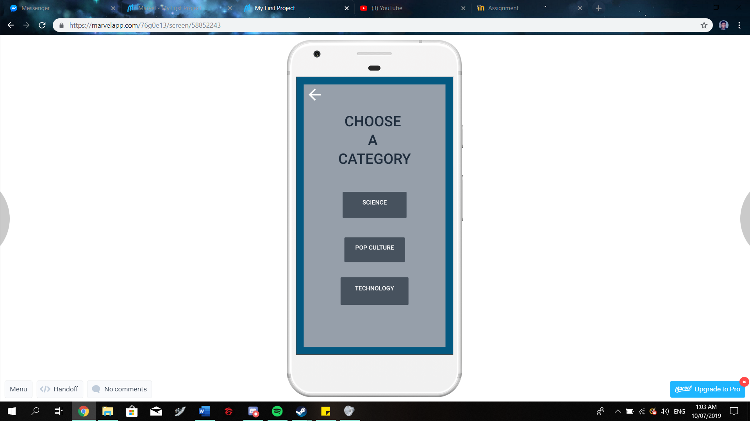

This is the Title screen. The user will be directed here upon launch

This is the category screen. The user can choose the category of his/her choice. The user can also return to the title screen by selecting the back button.

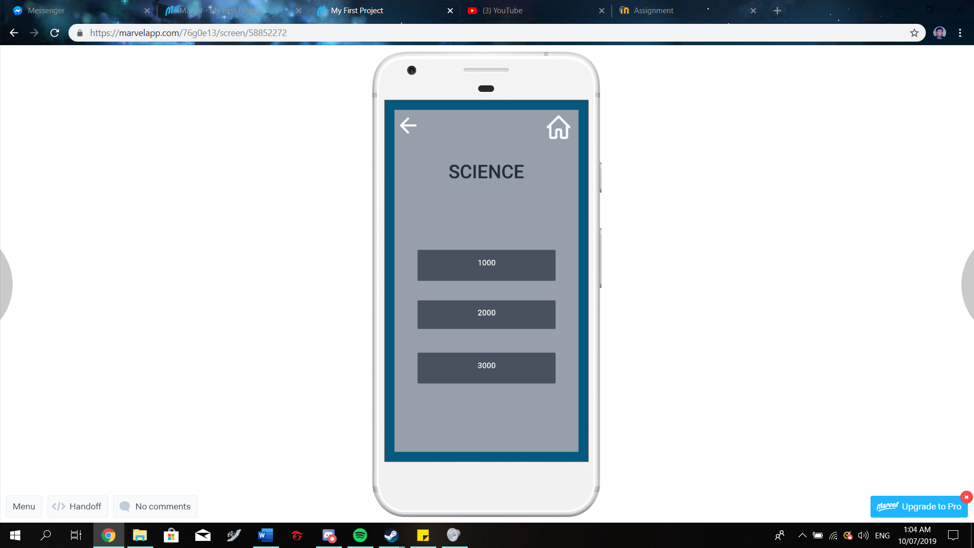 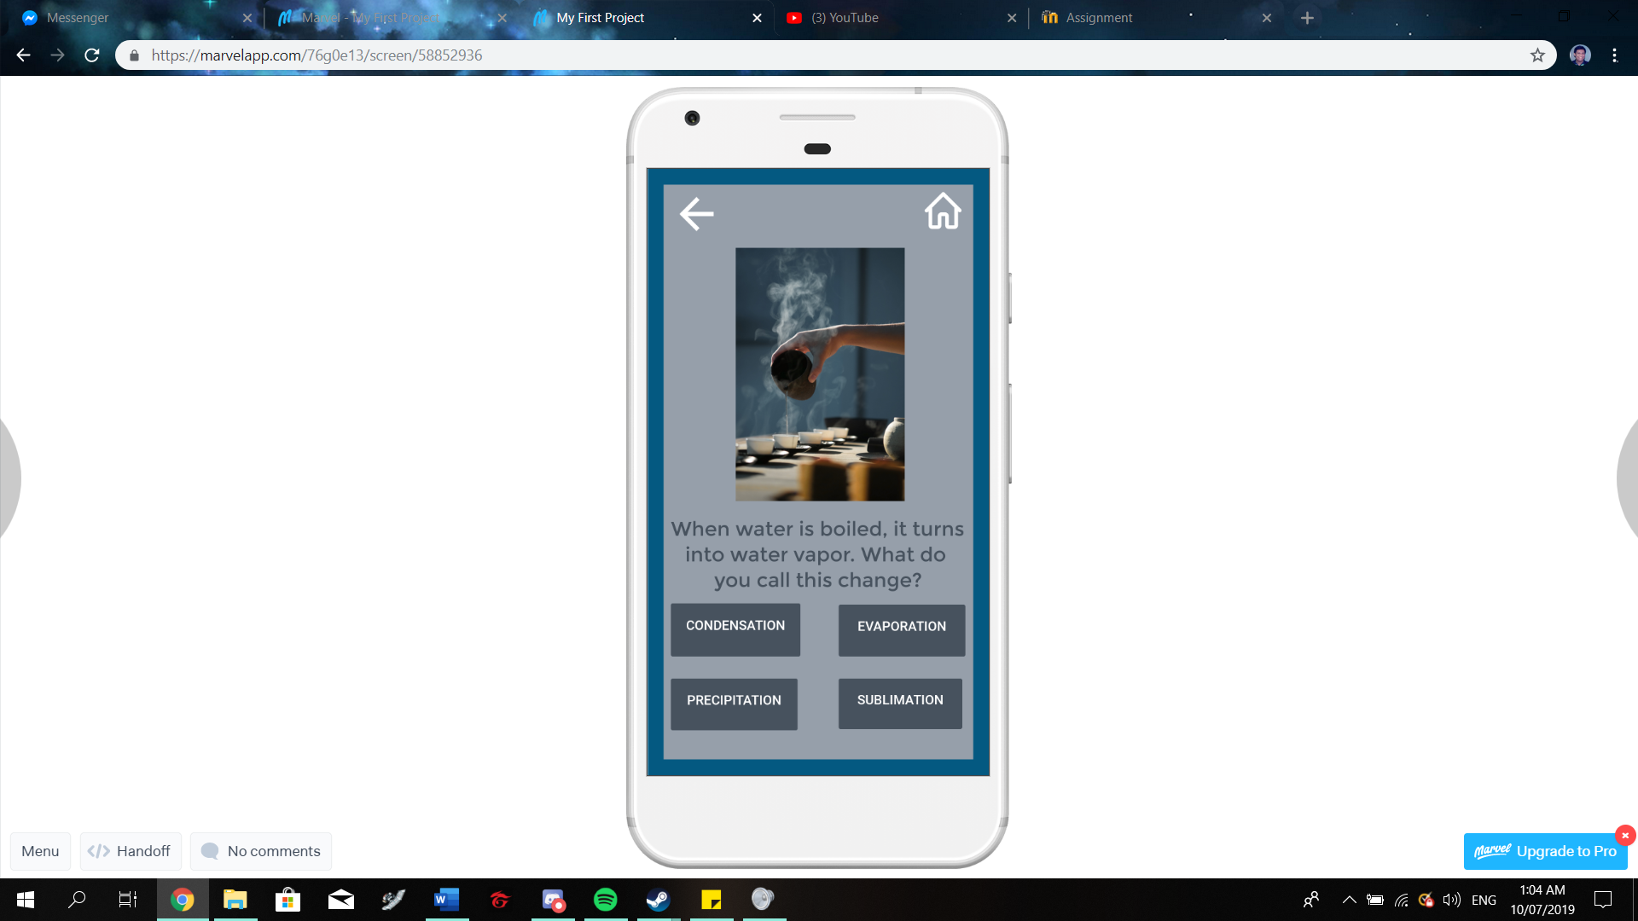

Upon choosing a category, the user can choose the question to be answered. The questions will have different scores depending on difficulty. The user can return to the previous page or title screen via back and home buttons

A sample question.

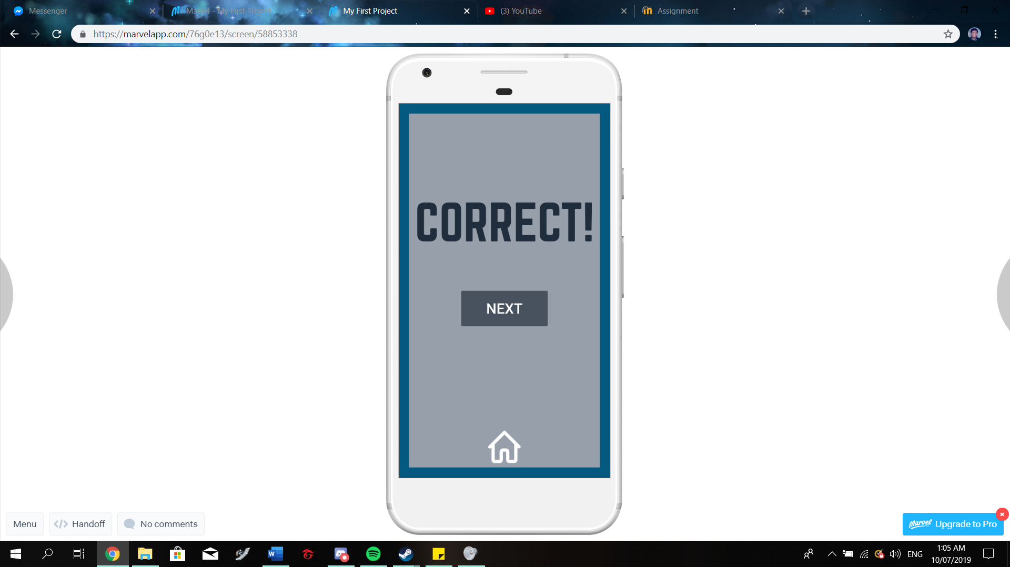 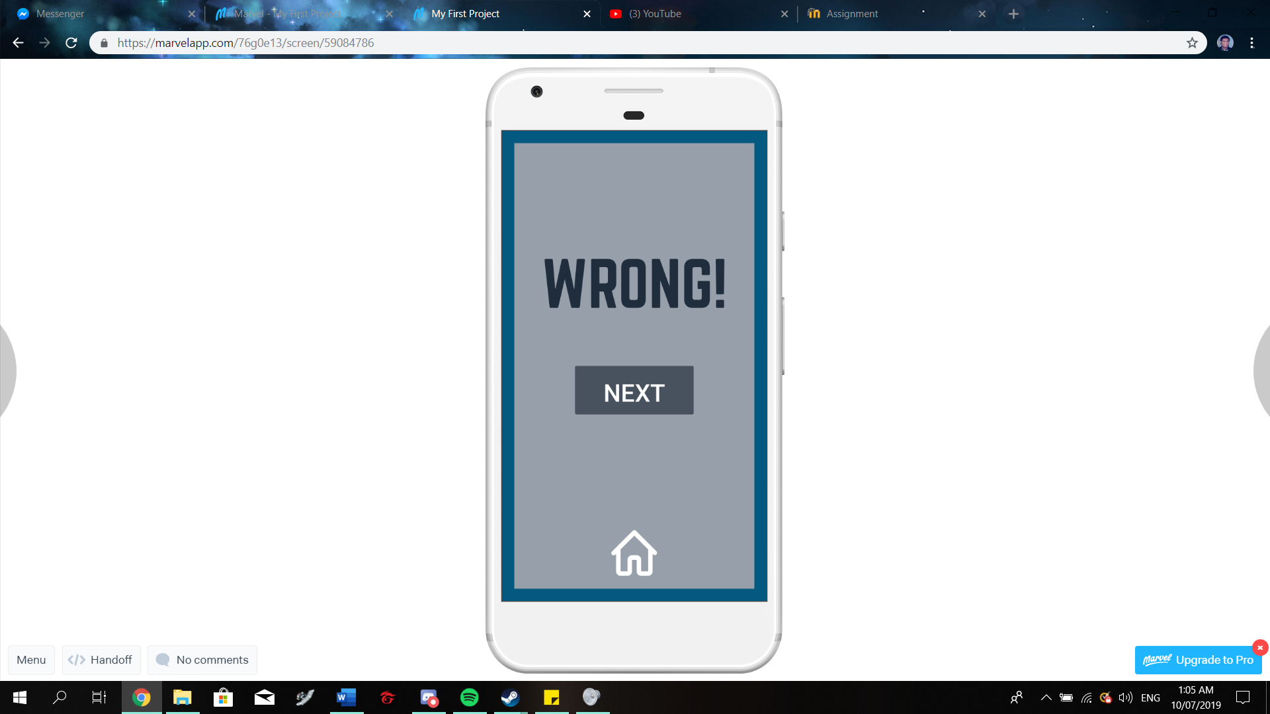

The result screens. If the user answers correctly, the correct screen will appear, if not, then the wrong screen will play out. Both screens have a ‘next’ button that will return to the question selection screen. Both screens also have a home button if the user wishes to return to title screen